A Shopping trip

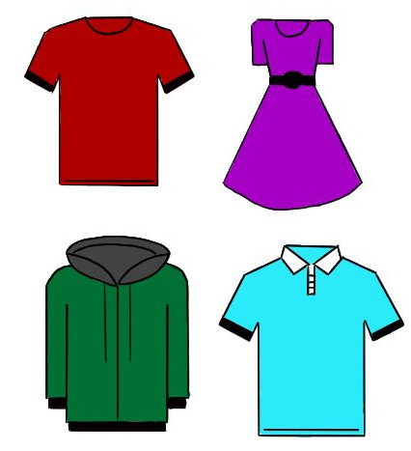
Create an exciting fashion intro like clothes doing some effects on cover page with title: A shopping trip

1. The first week of school has been quite stressful for the students of Outspoken High, there have been a lot of tests and quizzes, the students are also trying to adjust to the new formulas and equations.
Iris,Maya and Asuka in classroom looking tired and helpless with math figures flying in bubbles above

2. Iris, Maya and Asuka have decided to go shopping on this beautiful summers day, a much-needed day to relax and walk around the shopping centre. The air is filled with the delicious, mouth-watering smell of fresh chocolate doughnuts, that wafted from the coffee shop through the entire shopping centre.
Shopping centre scene with 3 girls excitedly walking in a mall surrounded by cafes coffees shops ,clothing shops etc

3.“Where are we going first? Food court, boutique, or stationery?! Oh, I am so excited!”, shrieks Asuka. The girls squeal in excitement, it has been a long time since they have been out on a magnificent day. “Perhaps we should glance at some clothing, purchase a dazzling dress, and then get some yummy lunch!”, Iris explains enthusiastically.
Girls scene at mall with 3 speech bubbles showing thought of food, clothing and stationery in each

4. The three girls decide to go to the shop to browse at formal evening gowns, perhaps for the formal dance towards the middle of the year. It is a fundraiser, where students raise money for the less fortunate students from other schools, supplying them with stationery, clothing and textbooks.
Formal dance at outspoken with banner-fundraiser in a bubble, 3 girls enter a formal dress boutique

5. A beautiful designer dress catches Maya’s gaze, it is love at first sight! “I must have this!”, shrieks Maya, in excitement. It is magnificent with intricate beadwork at the neck and an fjmjkm decides to try it on. “Oh my gosh! That is so gorgeous, Maya!”, says Asuka, admiring her. Iris looks at the price it, it sure does cost quite a bit of money. Iris shows Maya the tag, “Oh my! That is a lot. I think I would rather buy something much cheaper and donate at the fundraiser. I really do not need such an expensive dress and I would love to help more students,” says Maya.
Picture of maya with a beautiful beaded dress. And iris showing tag of dress to maya

6.They carry on walking throughout the shopping centre, looking at everything they could possibly think of. The girls get some doughnuts and coffee; what a lovely day it was and how responsible Maya is to put someone else’s needs before herself, she truly is a wonderful person.
Doughnuts , coffee scene..last

